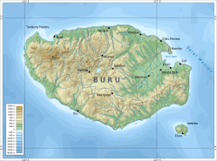
TANAH AIRKU INDONESIA
Sentence Exercises

Write these in English.

1. Pulau ini namanya pulau Bangka.

2. Satu kota besar di pulau Bangka namanya kota Pangkalpinang.

3. Kira-kira enamratus duapuluh tujuh ribu orang tinggal di pulau Bangka.

4. Pulau Bangka cukup besar dan dekat pulau Sumatra.

Now write these in Indonesian!

5. This island is called Buru island.

6. One big town on Buru island is called Namlea.

7. About 162,000 people live on Buru island.

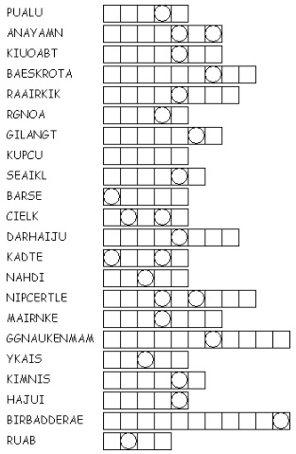
8. Buru island is small and very far from Jakarta.

Unscramble these words to find the hidden phrase about islands!
What is the hidden phrase?

_ D _ / B _ N Y _ K / P _ L _ _ / D _

_ N D _ N _ S _ A

