Rules:
Round 1: Roll the dice and move your piece. If you tell the time correctly, you remain on that clock and it is the next person’s turn. If you answer incorrectly, move back to the start (mulai). First person to reach selesai (finish) wins.
Round 2: Play as in round 1, but you must also pick up a sport/subject card and put the time and the sport/subject into a sentence. E.g. Pada jam tiga saya belajar musik (At 3 o’clock I study music).
Tennis | Tenis
Basketball | Bola basket
Soccer | Sepak bola
Maths | Matematika
History | Sejarah
Art | Kesenian
Music | Musik
English | Bahasa Inggris
Indonesian | Bahasa Indonesia
Geography | Geografi
PE | Penjas
Science | IPA
Round 3: Play as in round 2, but you must also pick up a ‘day of the week’ card and include it in your answer. E.g. Pada hari Senin saya belajar musik pada jam tiga (On Monday I study music at 3 o’clock).
Monday | Hari Senin
Tuesday | Hari Selasa
Wednesday | Hari Rabu
Thursday | Hari Kamis
Friday | Hari Jumat
Saturday | Hari Sabtu
Sunday | Hari Minggu
Answers:
1. | 3:00 | Jam tiga
2. | 4:35 | Jam lima kurang dua puluh lima
3. | 4:40 | Jam lima kurang dua puluh
4. | 2:25 | Jam dua lewat dua puluh lima
5. | 1:55 | Jam dua kurang lima
6. | 2:15 | Jam dua lewat seperempat
7. | 8:30 | Jam setengah sembilan
8. | 3:15 | Jam tiga lewat seperempat
9. | 4:00 | Jam empat
10. | 1:30 | Jam setengah dua
11. | 7:55 | Jam delapan kurang lima
12. | 7:45 | Jam delapan kurang seperempat
13. | 6:05 | Jam enam lewat lima
14. | 4:50 | Jam lima kurang sepuluh
15. | 7:10 | Jam tujuh lewat sepuluh
16. | 12:25 | Jam dua belas lewat dua puluh lima
17. | 11:15 | Jam sebelas lewat seperempat

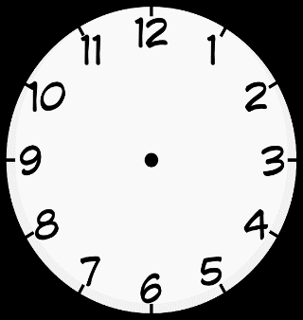
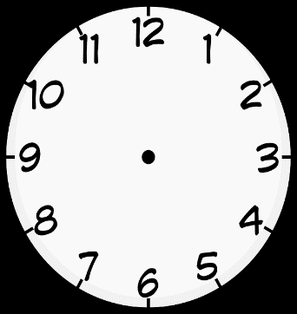
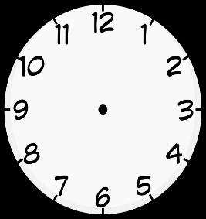
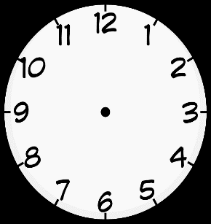
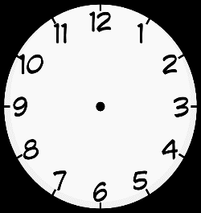
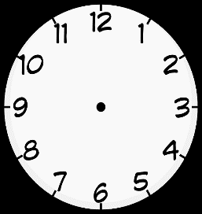
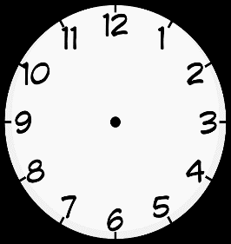
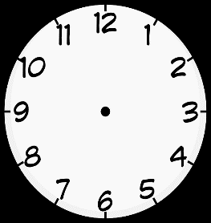
4:35
12:25
6:05
7:55
3:15
2:25
SELESAI
MULAI
Monday | Tuesday | Wednesday | Thursday
Friday | Saturday | Sunday | Tennis
Basketball | Soccer | Mathematics | History
Art | Music | English | Indonesian
Geography | PE | Science

