**Olahraga dan Hobi**

**Futbal Australia**

**In this unit, you will be able to:**

Topic 1: AFL Team Names

* *Say the names of the 18 AFL teams in Indonesian*
* *Recognize the differences between Indonesian & English word order when using adjectives*
* *Use adjectives in the correct word order in Indonesian*
* *Write a sentence in Indonesian saying which AFL team is your favourite*

Topic 2: Likes & Dislikes

* *Say which AFL teams you like, really like or dislike in Indonesian*
* *Ask & answer simple questions about likes & dislikes in Indonesian*
* *Use the question word “Apakah” when asking Yes/No questions in Indonesian*
* *Have a simple conversation in Indonesian regarding likes & dislikes*
* *Write a sentence in Indonesian about what teams other people like/dislike*

Topic: Colours

* *Say a range of different colours in Indonesian*
* *Use the adjectives “tua/muda” to describe light & dark colours*
* *Use correct word order when using adjectives in Indonesian*
* *Write a sentence in Indonesian about what colours your favourite team wears*

Topic: Numbers

* *Say a range of 1, 2 & 3 digit numbers in Indonesian*
* *Recognize word patterns to say different numbers in Indonesian*

Topic: Cultural Awareness: AFL Asia / AFL Indonesia

* *Recognize that some cultural items in Indonesia are influenced by other cultures and have connections to each other*
* *Recognize that other cultures have different ways of doing things*
* *Gain a deeper knowledge of Indonesian geography & cultural icons*

**Regu/Tim Futbal Australia (AFL Teams)**

|  |  |
| --- | --- |
| anjing bulldog |  |
| kucing | Kids — Geelong Cats Membership |
| pesawat bom |  |
| burung rajawali | Eagle Transparent PNG, Eagle Head, Bald Eagle Clipart Free Download - Free  Transparent PNG Logos |
| burung elang | Hawk PNG Images Transparent Background | PNG Play |
| burung murai | Magpie Bird PNG Image | Magpie, Bird, Wildlife art |
| burung gagak |  |
| bebek angsa | Download Swan Png Clipart HQ PNG Image | FreePNGImg |
| matahari |  |
| singah | Lion PNG, Lion Transparent Background - FreeIconsPNG |
| yang biru | Free Blue Splash Png, Download Free Blue Splash Png png images, Free  ClipArts on Clipart Library |
| kanguru |  |
| harimau |  |
| iblis |  |
| jangkar | Anchor PNG Cutout - PNG All |
| raksasa | Giant | Clash Royale Wiki | Fandom |
| yang suci | Saints transparent PNG images - StickPNG |
| tenaga | Sky, Lightning PNG Transparent Background, Free Download #44011 -  FreeIconsPNG |

**Topic: Adjective Word Order in Indonesian**

**Activity 1**

*Write the AFL team name in Indonesian under each AFL team logo.*



**Kucing Geelong** …………………………………………… ………………………………………………

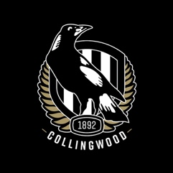****

………………………………………… …………………………………………. …………………………………………

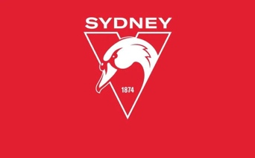

………………………………………….. …………………………………………….. ………………………………………….

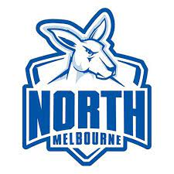

…………………………………………… …………………………………………. …………………………………………….



……………………………………….. ………………………………………. ………………………………………………

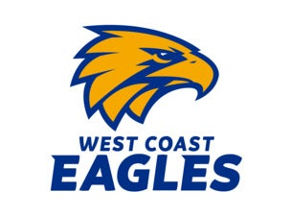

………………………………………….. …………………………………………………. ……………………………………………..



………………………………………………………………..!!!!!

**Answer these questions:**

**Regu/Tim favorit kamu apa?**

(What is your favourite team’s name?)

**Regu/Tim favorit saya……………………………………………………………………………………**

**INDONESIAN WORD ORDER ALERT!!!!**

**\*\*\*What have you noticed about Indonesian word order compared to English when using adjectives (describing words)?**

………………………………………………………………………………………………………………………………………..

……………………………………………………………………………………………………………………………………….

**Topic: Likes & Dislikes**

**Kamu suka tim apa? (What teams do you like?)**

**Suka = To like**

**\*Saya suka regu Singa Brisbane (I like Brisbane Lions)**

**suka sekali. = To really like/love**

**\*Saya suka sekali regu Anjing Barat.**

**(I love Western Bulldogs)**

**Tidak suka = To dislike**

**\*Saya tidak suka regu Kucing Geelong.**

**(I don’t like Geelong Cats)**

**Activity 1**

*Tick the correct box in the table according to how much you like or dislike the following AFL teams:*

|  |  |  |  |  |
| --- | --- | --- | --- | --- |
| **Regu/Tim AFL** | **Paling suka** | **Suka sekali** | **Suka** | **Tidak Suka** |
| Anjing Bulldog Barat |  |  |  |  |
| Kucing Geelong |  |  |  |  |
| Singa Brisbane |  |  |  |  |
| Kanguru Melbourne Utara |  |  |  |  |
| Pesawat Bom Essendon |  |  |  |  |
| Harimau Richmond |  |  |  |  |
| Matahari Gold Coast |  |  |  |  |
| Jangkar Fremantle |  |  |  |  |
| Tenaga Pelabuhan Adelaide |  |  |  |  |
| Burung Rajawali Pantai Barat |  |  |  |  |
| Burung Elang Hawthorn |  |  |  |  |
| Burung Murai Collingwood |  |  |  |  |
| Bebek Angsa Sydney |  |  |  |  |
| Raksasa Sydney Barat Raya |  |  |  |  |
| Iblis Melbourne |  |  |  |  |
| Yang Biru Carlton |  |  |  |  |
| Yang Suci St Kilda |  |  |  |  |
| Burung Gagak Adelaide |  |  |  |  |

**Activity 2**  
*Now ask some different people in the class whether they like or dislike the 18 AFL teams.*

*\*\*Write the name of each person you ask in the appropriate box for each team according to how much they like/dislike the teams.*

**Apakah kamu suka regu/tim…….?**

(Do you like………………?)

Ya, saya suka. (Yes, I like them)

Ya, saya suka sekali. (Yes, I love them)

Tidak. Saya tidak suka. (No, I don’t like them)

**Activity 3**

*Write 2 sentences about which AFL teams other people in your class like/don’t like.*

Example: *John* ***suka*** *regu Tenaga Port Adelaide* ***dan*** *regu**Kucing Geelong,* ***tetapi*** *dia* ***tidak suka*** *regu Harimau Richmond*

**Topic: Warna-Warna (Colours)**

**Regu/Tim kamu memakai warna apa?**

(What colours does your team wear?)

|  |  |
| --- | --- |
| warna biru | blue |
| warna biru tua | dark blue |
| warna biru muda | light blue |
| tua | dark |
| muda | light |
| warna jingga | orange |
| warna coklat | brown |
| warna putih | white |
| warna ungu | purple |
| warna kuning | yellow |
| warna merah | red |
| warna merah muda | pink |
| warna hitam | black |
| warna hijau | green |
| warna abu-abu | grey |
| warna | colour |

**Activity 1**

*Label the AFL team jersey colours in Indonesian & write the team name of each one in Indonesian underneath it. **Kaos = jersey*

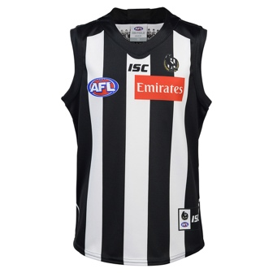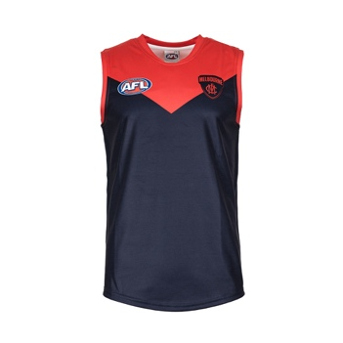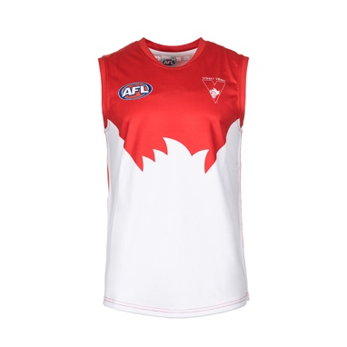

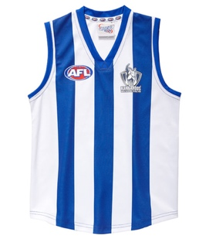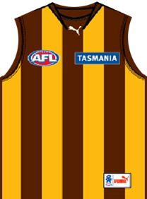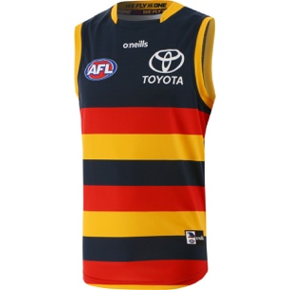

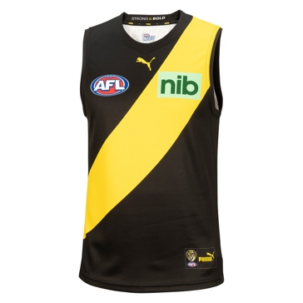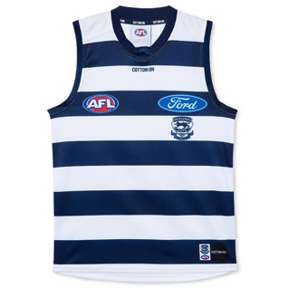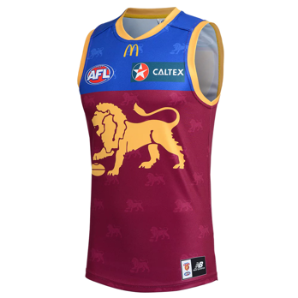

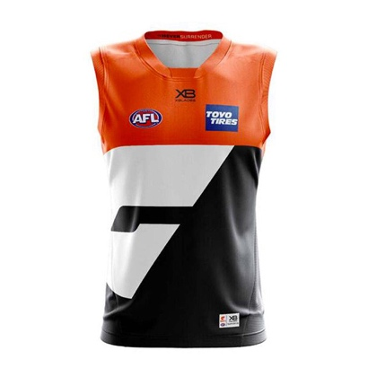

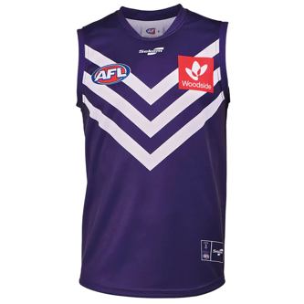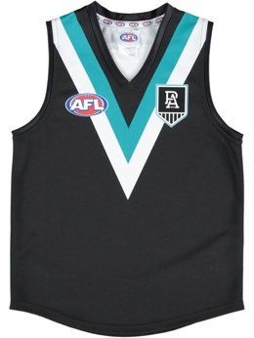

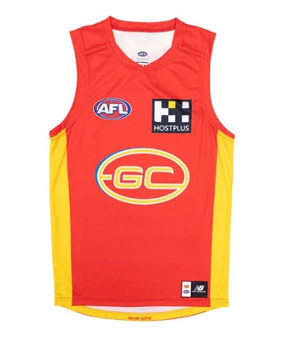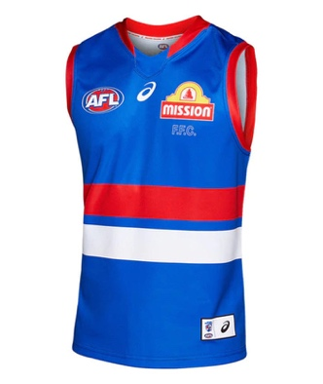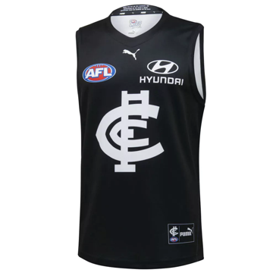

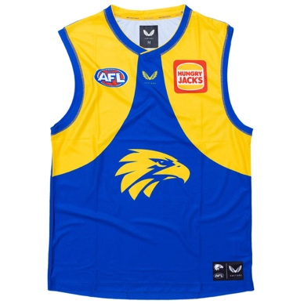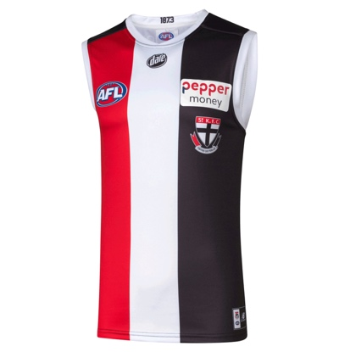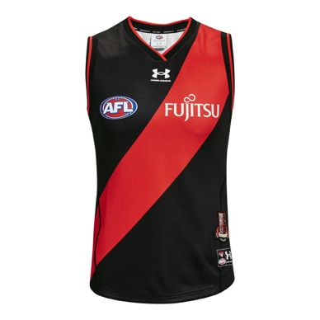

**Activity 2**

*Write a sentence in Indonesian about what colours your favourite team wears.*

Example: Regu/Tim favorit saya **memakai** kaos warna merah, warna putih **dan** warna biru.

……………………………………………………………………………………………………

…………………………………………………………………………………………………..

**Topic: Nomer (Numbers)**

|  |  |
| --- | --- |
| **satu** | **1** |
| **dua** | **2** |
| **tiga** | **3** |
| **empat** | **4** |
| **lima** | **5** |
| **enam** | **6** |
| **tujuh** | **7** |
| **delapan** | **8** |
| **sembilan** | **9** |
| **sepuluh** | **10** |
| **belas** | **word for all teen numbers** |
| **sebelas** | **11** |
| **dua belas** | **12** |
| **tiga belas** | **13** |
| **puluh** | **word for all tens numbers** |
| **dua puluh** | **20** |
| **dua puluh lima** | **25** |
| **ratus** | **word for all hundred numbers** |
| **seratus** | **100** |
| **dua ratus** | **200** |
| **ribu** | **word for all thousand numbers** |
| **seribu** | **1000** |
| **dua ribu** | **2000** |

**Activity 1**

*Here is the AFL ladder at the end of the 2022 season.*

*Fill in the table below with the total points each team finished with in Indonesian numbers.*

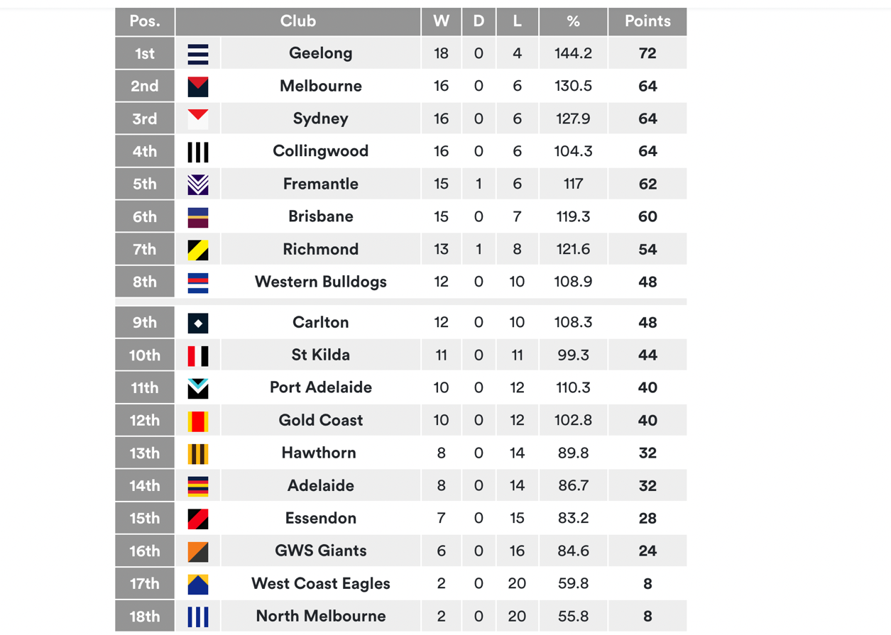

|  |  |  |
| --- | --- | --- |
| **Klasemen** | **Regu/Tim** | **Poin** |
| **Pertama** | Kucing Geelong | **tujuh puluh dua (72)** |
| **Kedua** | Iblis Melbourne | **enam puluh empat (64)** |
|  | Angsa Sydney |  |
|  | Burung Murai Collingwood |  |
|  | Jangkar Fremantle |  |
|  | Singa Brisbane |  |
|  | Harimau Richmond |  |
|  | Anjing Bulldog Barat |  |
|  | Yang Biru Carlton |  |
|  | Yang Suci St Kilda |  |
|  | Tenaga Pelabuhan Adelaide |  |
|  | Matahari Gold Coast |  |
|  | Burung Elang Hawthorn |  |
|  | Burung Gagak Adelaide |  |
|  | Pesawat Bom Essendon |  |
|  | Raksasa Sydney Barat Raya |  |
|  | Burung Elang Muda Pantai Barat |  |
|  | Kanguru Melbourne Utara |  |

|  |  |  |
| --- | --- | --- |
| **Klasemen** | **Regu/Tim** | **Poin** |
| **Pertama** | Kucing Geelong | **Tujuh puluh dua (72)** |
| **Kedua** | Iblis Melbourne | **Enam puluh empat (64)** |
|  | Angsa Sydney |  |
|  | Burung Murai Collingwood |  |
|  | Jangkar Fremantle |  |
|  | Singa Brisbane |  |
|  | Harimau Richmond |  |
|  | Anjing Barat |  |
|  | Yang Biru Carlton |  |
|  | Yang Suci St Kilda |  |
|  | Tenaga Port Adelaide |  |
|  | Matahari Gold Coast |  |
|  | Burung Elang Hawthorn |  |
|  | Burung Gagak Adelaide |  |
|  | Pesawat Bom Essendon |  |
|  | Raksasa GWS |  |
|  | Burung Elang Muda Pantai Barat |  |
|  | Kanguru North Melbourne |  |

**Activity 2**

*Look at the top 8 teams.*

*Write their percentages in whole Indonesian numbers.*

*(**Don’t use the decimal number!)*

|  |  |
| --- | --- |
| Geelong Fan Circle Pin | seratus empat puluh empat  1 4 4 |
| Afl Pins and Buttons for Sale | TeePublic |  |
| Swans Pin |  |
| Black & White Pin |  |
| FULL TIME: FULL TIME: Fremantle vs St Kilda - Round 2, 2022 - AFL News -  Zero Hanger |  |
| Port Adelaide v Brisbane Lions | AFL | Australian Rules |  |
| AFL Player Statistics | AFL Stats - Zero Hanger |  |
| FULL TIME: Bulldogs vs GWS - Round 22, 2022 - AFL News - Zero Hanger |  |

**Topic: Cultural Awareness: AFL Asia / AFL Indonesia**

*AFL in Indonesia?????*

*Indonesians playing footy???*

*AFL leagues in other countries beside Australia???*

*Believe it or not…….YES it’s TRUE!!!!*

Recently, over the last several years, Indonesia has begun to get interested in Australian Rules football (footy), which is not a usual sport in Indonesia.

With the help of some ex-AFL coaches who moved to Jakarta for work or personal reasons, there is now a professional league called “AFLI” (Australian Football League Indonesia), which is part of AFL Asia, among countries like Japan, India and Korea.

This is the logo of AFLI. (Look familiar???)



**Task 1 – AFLI Background**

*Go to this website (or any other you can find) and answer these questions:*

Website Name: **AFL (Indonesia) – AustralianRulesFootball.com.au**

<http://australianrulesfootball.com.au/pages/aflindonesiaas>

1. What year was the AFLI formed?

……………………………………………………………………………………..

1. What are the representative colours of the AFLI?

……………………………………………………………………………………..

1. How many teams are in the AFLI?

………………………………………………………………………………………

1. Name the teams.

……………………………………………………………………………………………………………………………………………………………………………………..

1. Which cities/islands are the teams from? (*YOU WILL NEED TO FIND OUT IF THESE PLACES ARE CITIES OR ISLANDS)

…………………………………………………………………………………………………………………………………………………………………………………….

1. Looking at the “trophy cabinet” section on the website, which team has been the most successful?

…………………………………………………………………………………………………………………………………………………………………………………….

1. How many competitions have there been? Name them.

……………………………………………………………………………………………………………………………………………………………………………………………………………………………………………………………………………….

**Task 2 – The Teams of the AFLI**

*Fill in this table with information about the teams in the AFLI:*

|  |  |  |  |  |
| --- | --- | --- | --- | --- |
| **Team Name** | **Year Formed** | **Colours** | **From which city** | **From which island** |
| Bali Geckos |  |  |  |  |
| Borneo Bears |  |  |  |  |
| Jakarta Bintangs |  |  |  |  |
| Jakarta Bulldogs |  |  |  |  |

**Task 3 – Redesigning the AFLI Logo**

*The AFLI would like to change their logo to a new one that represents Indonesia more & is more unique than the current one, which is very similar to the AFL.*

*You have been given the job of redesigning the logo of the AFLI.*

*Draw your FINAL design below.*

Make sure you meet the following criteria:

* Must have the words “AFL Indonesia”
* Must be completely DIFFERENT to the current one & Australia
* Must represent Indonesia as a country, e.g. use Indonesian icons in the design to make it unique to Indonesia
* Must stand out as AFL INDONESIA!

**Preparation for Designing a New AFLI Logo**

1. Use the Internet to find out what the names of these Indonesian icons are & write them below the pictures.

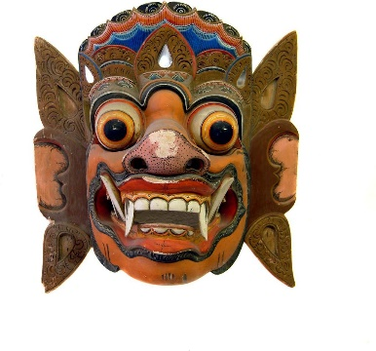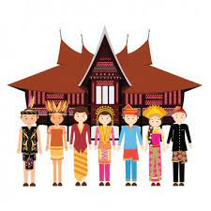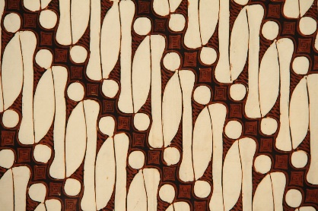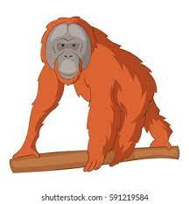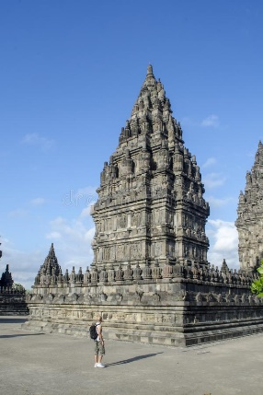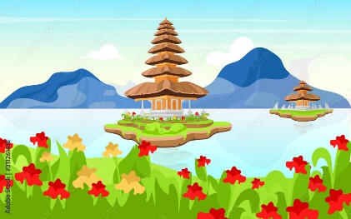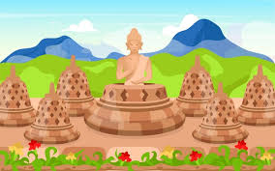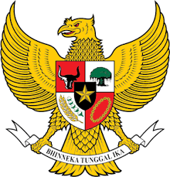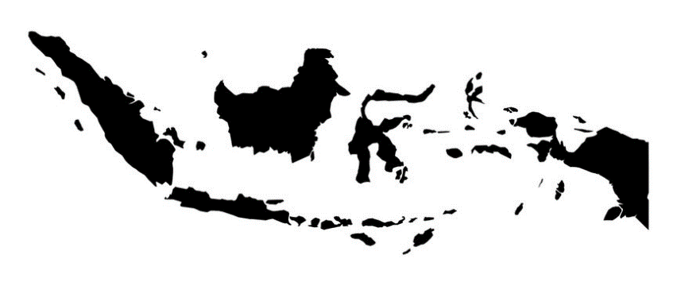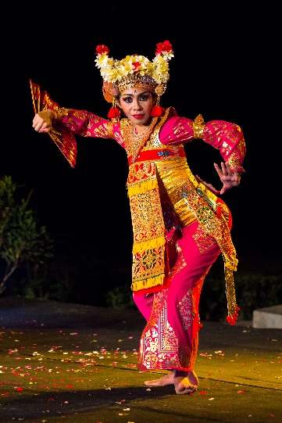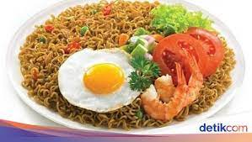

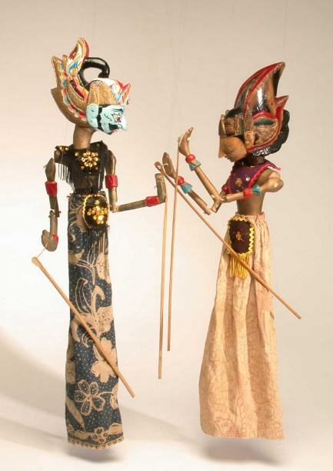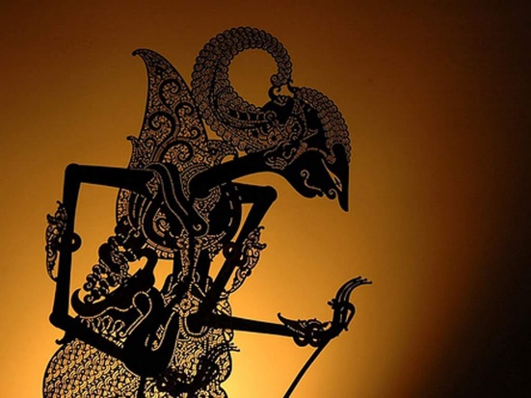

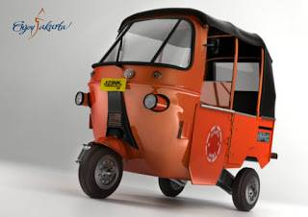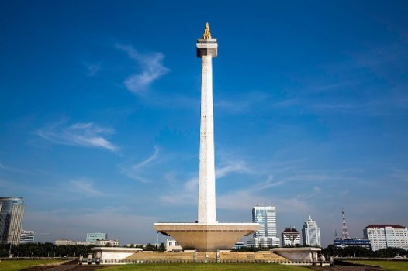

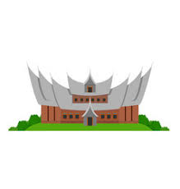

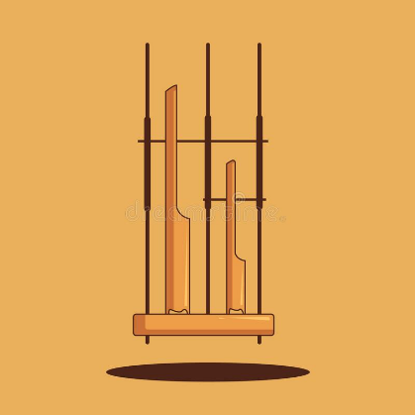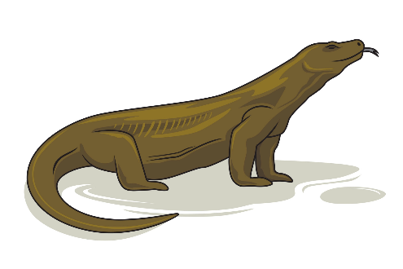

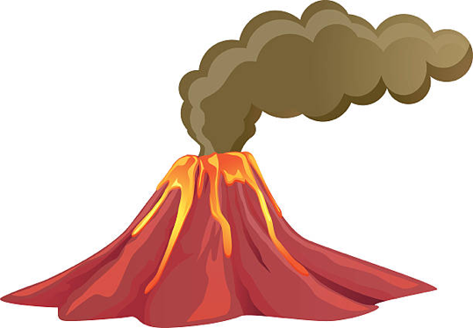

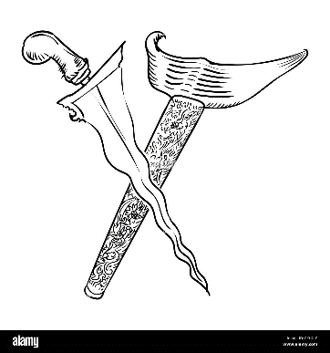

1. Find some more icons of Indonesia.

Draw them in the box below.

1. Decide what icon or icons you are going to use for your new AFLI logo.

Draw a ROUGH plan of your logo below.

**Your logo MUST contain at least ONE icon of Indonesia AND the words AFLI.

**Task 4 – Creating a New AFLI Team & Logo**

* *Look at the names, logos and mascots of the following teams:*

[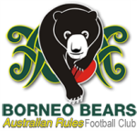](http://www.borneobears.com/)[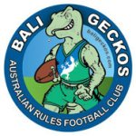](http://baligeckos.org/)

(Geckos are everywhere in Indonesia!) A native animal on the island of Borneo

(Kalimantan) is a sun bear

[](http://www.facebook.com/group.php?gid=5327784524#!/group.php?gid=5327784524&v=info)[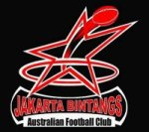](http://www.bintangs.com/)

(Bintang is a famous beer from Indonesia, Now THAT’S just a copy of the AFL’s

but the word itself means “star”) best team!!

**Task Instructions**

The AFLI needs more teams!

You have been given the job to start a NEW team that YOU will manage!

Follow these instructions:

* Choose another city or island of Indonesia that DOES NOT YET have an AFLI team
* 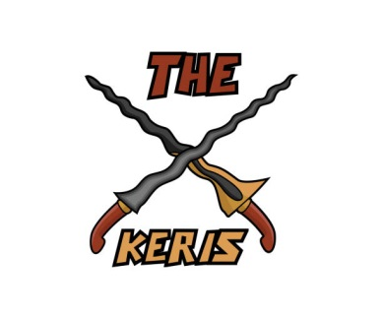Create a name for your new AFLI team (*make sure it’s catchy & matches the city/island – look at icons!)
* Create a logo and mascot for your team

**Example:**

City Name: Yogjakarta, (Java Island) Logo:

Famous Icon from Yogjakarta: Javanese Keris swords

New AFLI Team Name: The Yogjakarta Keris

**Yogjakarta**

**Keris**

Chant: “Fear the KERIS…..The blades of death!”

**Australian Rules Football Club**

*Draw your logo below with your team name & mascot:*

**Task 5 – The Indonesian National AFL Team**

Did you know that Indonesia has a NATIONAL AFL team that represents the whole country in competitions in countries in Asia and in Australia????

Did you know that the Indonesian AFL National team regularly comes to Melbourne (known as the home of the AFL!) to both train and compete???

**YES…..It’s TRUE!!!**

The Indonesian AFL National team is known as “The Indonesia Garudas” (surprise surprise!)

**Quick Question**

Why do you think the AFL Indonesia national team is known as The Indonesia Garudas?

…………………………………………………………………………………………………

**Task Instructions**

*You are going to watch some AFL Indonesia Promotional Videos on Youtube.*

[*https://www.youtube.com/watch?v=UHbQikF2_aM*](https://www.youtube.com/watch?v=UHbQikF2_aM)

*https://www.youtube.com/watch?v=iyFWiVv3vF0*

[*https://www.youtube.com/watch?v=lX6OU88HPZ8*](https://www.youtube.com/watch?v=lX6OU88HPZ8)

*Answer the following questions:*

1. What are they preparing for?

…………………………………………………………………………………………

1. What is special about the Garudas?

………………………………………………………………………………………

1. Is it easy for all the players to get to practice? How do you know?

…………………………………………………………………………………………

1. What are some big strengths of Indonesian players in footy according to their Aussie team mates?

……………………………………………………………………………………………………………………………………………………………………………………

1. What kinds of backgrounds do the Indonesian players come from?

…………………………………………………………………………………………

1. Besides enjoyment of the game, what is another reason for the Indonesians to want to play footy?

…………………………………………………………………………………………

1. Watching the video, which AFLI team do many of the players come from?

…………………………………………………………………………………………

1. According to one Indonesian player, why is footy a really cool game?

……………………………………………………………………………………………………………………………………………………………………………………

1. What are some problems the team faces in terms of training and playing?

……………………………………………………………………………………………………………………………………………………………………………………

1. Do these problems put off the players and make them give up playing?

…………………………………………………………………………………………

1. List some similarities and differences between footy in Indonesia and footy in Australia that you see in the video:

**Similarities Differences**

1. What is your personal opinion about the Indonesian Garudas, the AFLI and footy in Indonesia in general?

…………………………………………………………………………………………………………………………………………………………………………………………………………………………………………………………………………………………………………………………………………………………………………………………………………………………………………………………………………………………………………………………………………………………………………………………………………………………………………………………

**Task 6 - Designing a Guernsey**

Choose a task:

1. Design a new guernsey for the AFL Indonesia National team “The Indonesian Garudas”
2. Design a guernsey for your new club you created in Task 4
3. 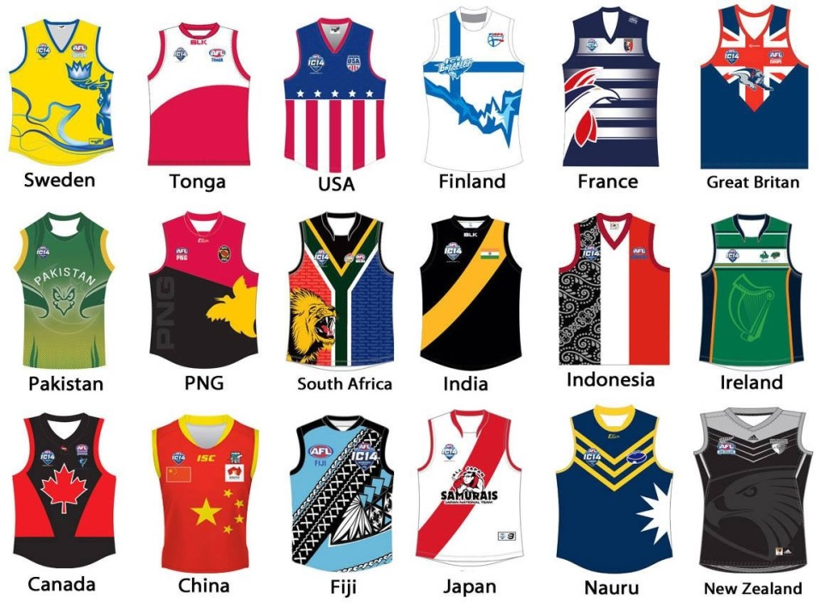Design a new name, logo and guernsey for the AFL Indonesia National team “The Indonesian Garudas”

