**Kasihan**

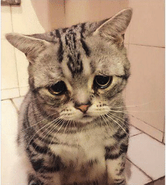

Poor little sausage