Olahraga dan Hobi
Futbal Rugby League
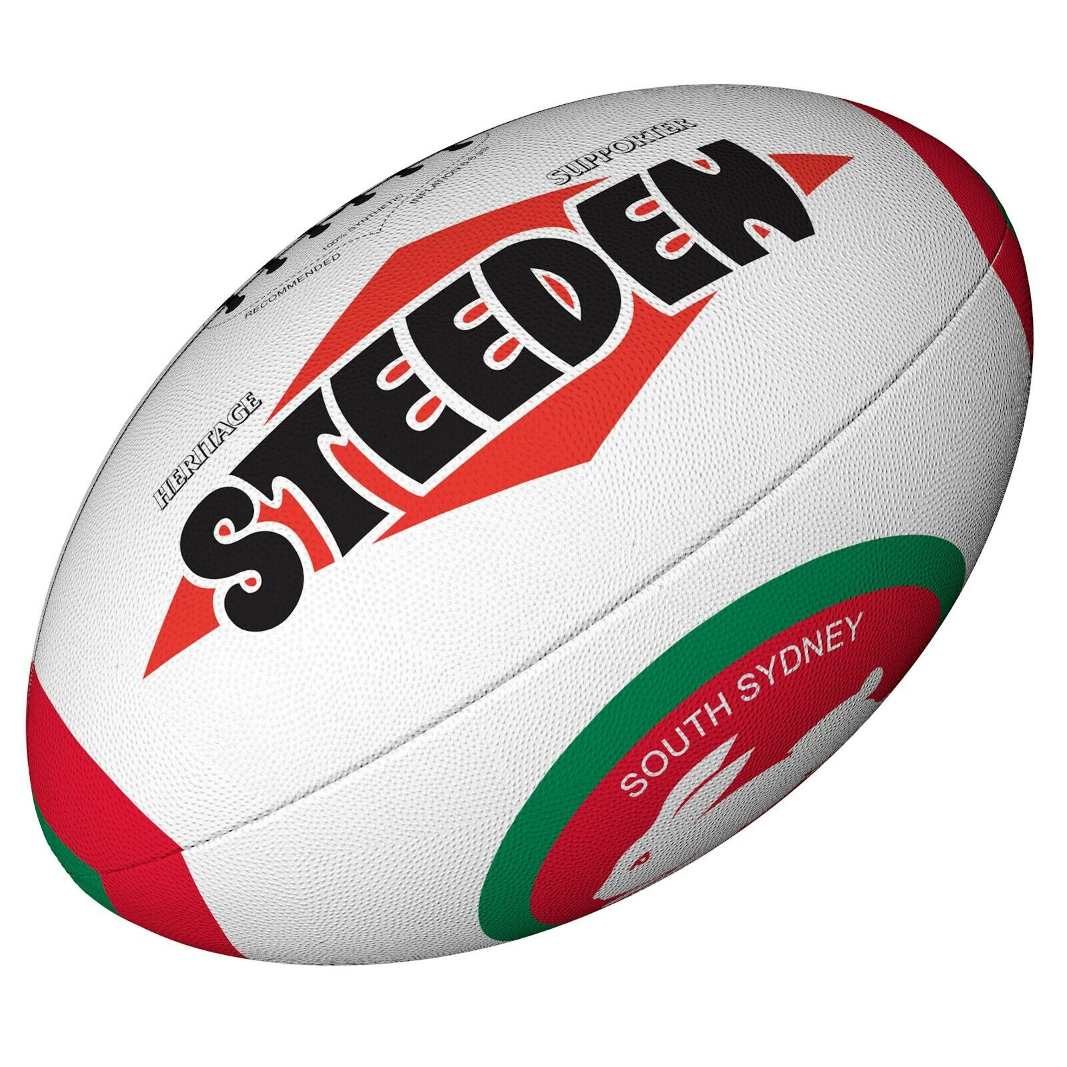
In this unit, you will be able to:

Topic 1: NRL Team Names

- Say the names of the 17 NRL teams in Indonesian
- Recognize the differences between Indonesian & English word order when using adjectives
- Use adjectives in the correct word order in Indonesian
- Write a sentence in Indonesian saying which NRL team is your favourite

Topic 2: Likes & Dislikes

- Say which NRL teams you like, really like or dislike in Indonesian
- Ask & answer simple questions about likes & dislikes in Indonesian
- Use the question word “Apakah” when asking Yes/No questions in Indonesian
- Have a simple conversation in Indonesian regarding likes & dislikes
- Write a sentence in Indonesian about what teams other people like/dislike

Topic 3: Colours

- Say a range of different colours in Indonesian
- Use the adjectives “tua/muda” to describe light & dark colours
- Use correct word order when using adjectives in Indonesian
- Write a sentence in Indonesian about what colours your favourite team wears

Topic 4: Numbers

- Say a range of 1, 2 & 3 digit numbers in Indonesian
- Recognize word patterns to say different numbers in Indonesian

Topic 5: International Popularity of Rugby League

- Recognize that Rugby League football is played in around 70 countries and is recognised as the national sport in some of these countries.
- Record statistical sporting data and complete competition tables for the recently completed 2022 Rugby League World Cup conducted in England.
- Learn to say the names of different countries where Rugby League is played in Indonesian

Topic 6: Establishing a Rugby League presence in Indonesia

- Create a logo for the Indonesian National Rugby League.
- Complete information of some imaginary teams that could form the foundation of a new Rugby League competition in Indonesia.
- Design a logo and club jersey for one of these imaginary clubs.

Regu/Tim Futbal Rugby League (NRL Teams)

Kelinci Sydney Selatan
Ayam Jantan Sydney
Belut Parramatta
Badai Melbourne
Burung Elang Laut Manly-Warringah | 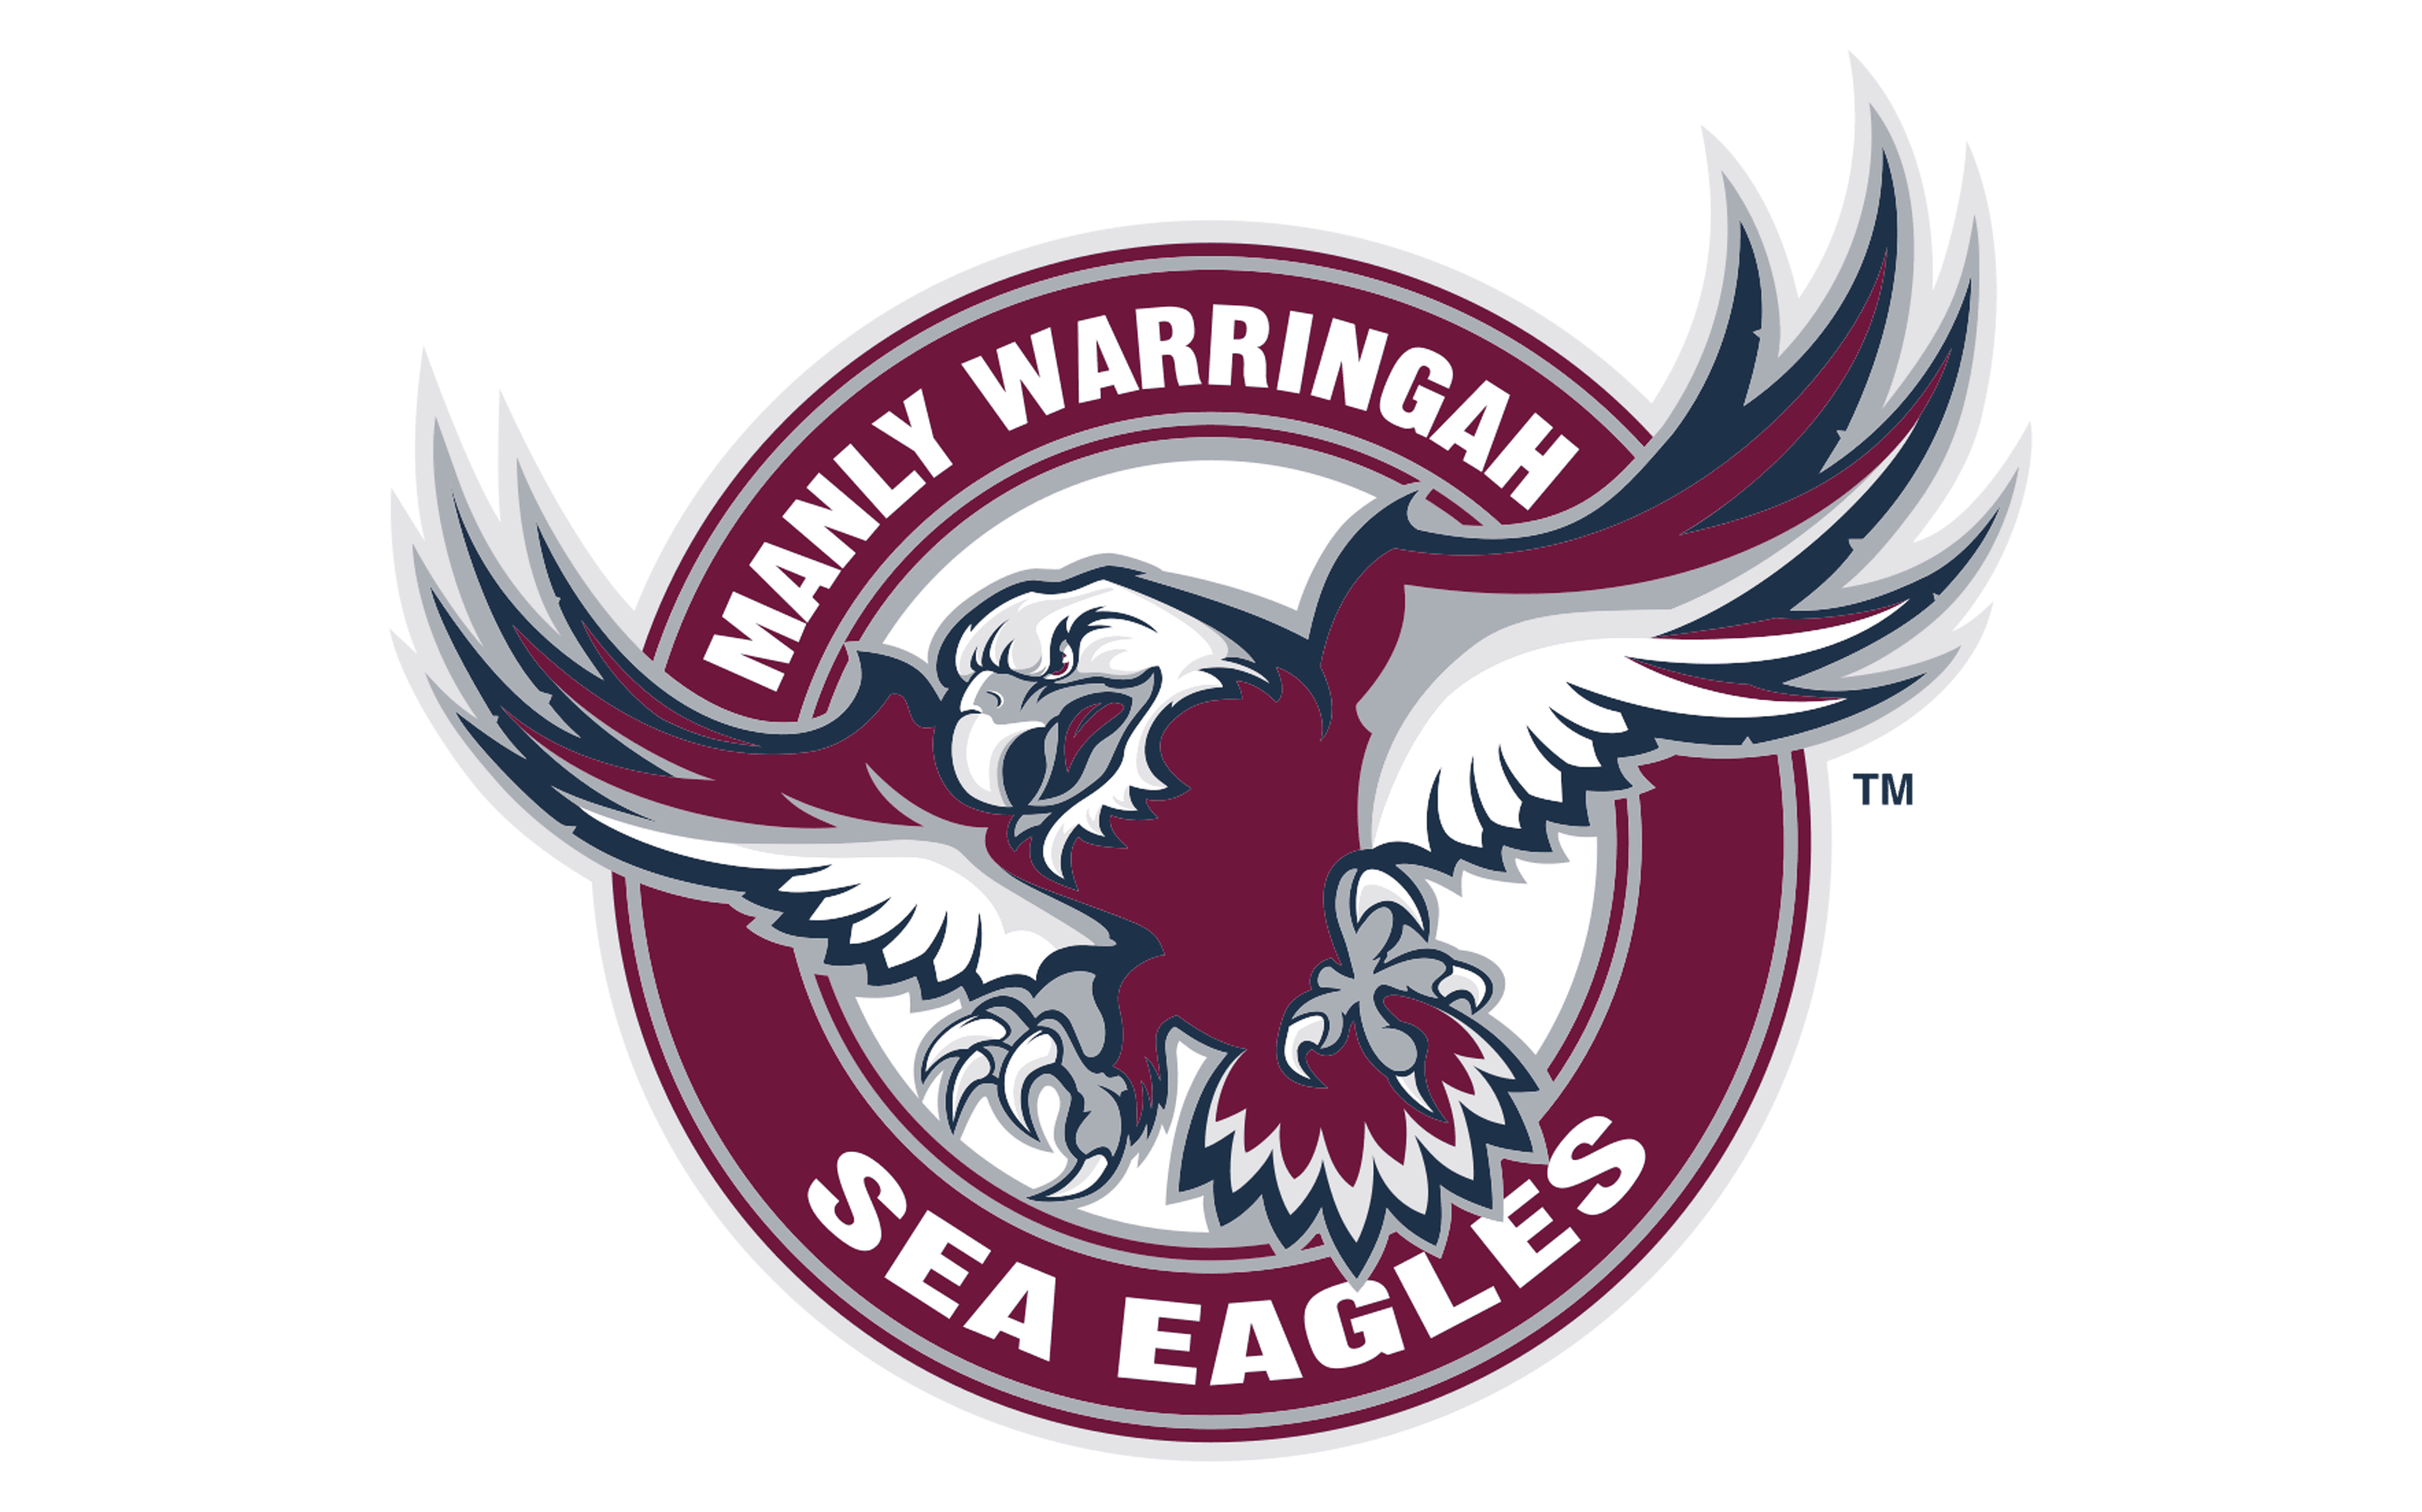
Harimau Sydney Barat
Kuda Bronco Brisbane
Raksasa Titan Pantai Emas
Harimau Kumbang Penrith
Penjarah Canberra
Ikan Hiu Cronulla | 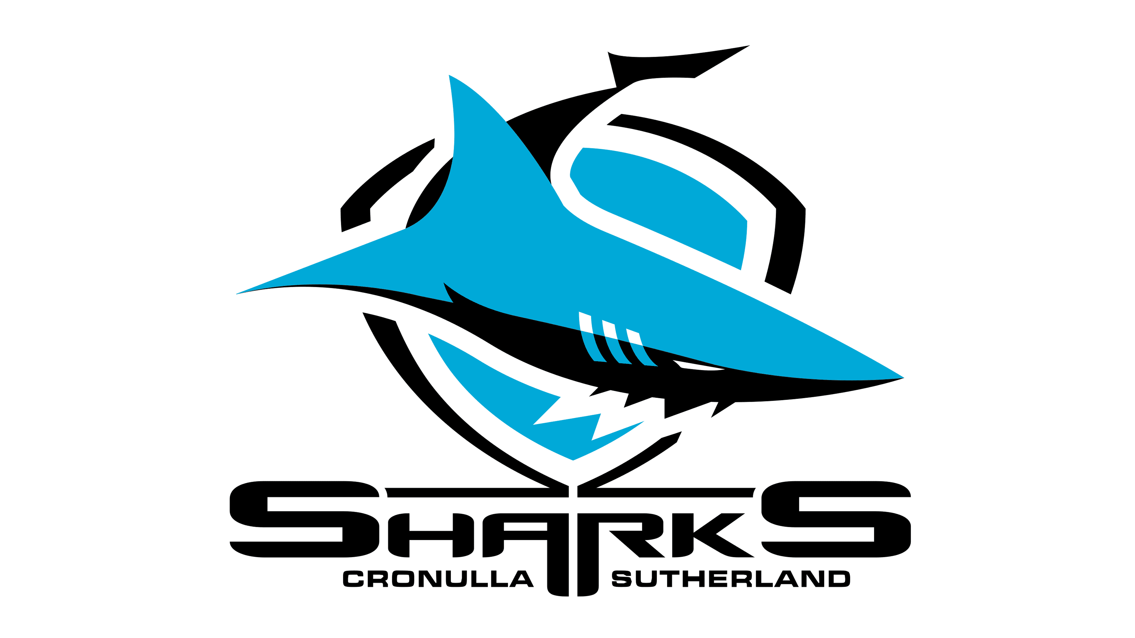
Koboi Queensland Utara
Lumba-Lumba Redcliffe | 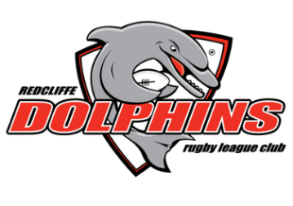
Prajurit Selandia Baru
Kesatria Newcastle
Anjing Buldog Canterbury
Naga St. George-Illawarra | 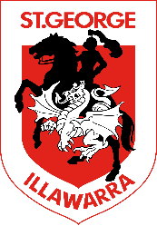

Topic: Adjective Word Order in Indonesian

Activity 1
Write the NRL team name in Indonesian under each NRL team logo.

…………………………………………………… | ……………………………………………………
…………………………………………………… | ……………………………………………………
…………………………………………………… | ……………………………………………………
…………………………………………………… | ……………………………………………………
…………………………………………………… | ……………………………………………………
…………………………………………………… | ……………………………………………………
…………………………………………………… | ……………………………………………………
…………………………………………………… | ……………………………………………………
……………………………………………………

Answer this question:

Regu/Tim favorit kamu apa?
(What is your favourite team’s name?)

Regu/Tim favorit saya adalah ………………………………………………………………………………

INDONESIAN WORD ORDER ALERT!!!!

***What have you noticed about Indonesian word order compared to English when using adjectives (describing words)? Provide an example in your answer.

………………………………………………………………………………………………………………………………………..

……………………………………………………………………………………………………………………………………….

……………………………………………………………………………………………………………………………………….

Topic: Likes & Dislikes

Kamu suka tim apa? (What teams do you like?)

Suka = To like

*Saya suka tim/regu Belut Parramatta (I like the Parramatta Eels)

suka sekali. = To really like/love

*Saya suka sekali tim/regu Kelinci Sydney Selatan.
(I love the South Sydney Rabbitohs)

Tidak suka = To dislike

*Saya tidak suka tim/regu Ayam Jantan Sydney.
(I don’t like the Sydney Roosters)

Activity 1
Tick the correct box in the table according to how much you like or dislike the following NRL teams:

Regu/Tim NRL | Paling suka | Suka sekali | Suka sedikit | Tidak Suka
Kelinci Sydney Selatan
Ayam Jantan Sydney
Belut Parramatta
Badai Melbourne
Burung Elang Laut Manly-Warringah
Harimau Sydney Barat
Kuda Bronco Brisbane
Raksasa Titan Pantai Emas
Harimau Kumbang Penrith
Penjarah Canberra
Ikan Hiu Cronulla
Koboi Queensland Utara
Lumba-Lumba Redcliffe
Prajurit Selandia Baru
Kesatria Newcastle
Anjing Buldog Canterbury
Naga St. George- Illawarra

Activity 2
Now ask some different people in the class whether they like or dislike the 18 NRL teams.
**Write the name of each person you ask in the appropriate box for each team according to how much they like/dislike the teams.
Apakah kamu suka regu/tim…….?
(Do you like the ………………?)

Ya, saya suka. (Yes, I like them)
Ya, saya suka sekali. (Yes, I love them)
Tidak. Saya tidak suka. (No, I don’t like them)

Activity 3
Write 2 sentences about which NRL teams other people in your class like/don’t like.

Example: John suka regu Kelinci Sydney Sleatan dan regu Belut Parramatta, tetapi dia tidak suka regu Badai Melbourne.

Topic: Warna-Warna (Colours)

Regu/Tim kamu memakai warna apa?
(What colours does your team wear?)

warna | colour
tua | dark
muda | light
biru | blue
biru tua | dark blue
biru muda | light blue
jingga | orange
coklat | brown
putih | white
ungu | purple
kuning | yellow
merah | red
merah muda | pink
hitam | black
hijau | green
abu-abu | grey

Activity 1
Write the team name and the colours of the NRL team jersey in Indonesian. **Kaos = jersey

Kaos | Nama Tim | Warna-Warna Kaos
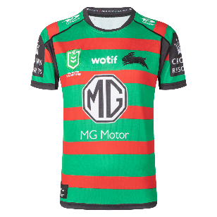
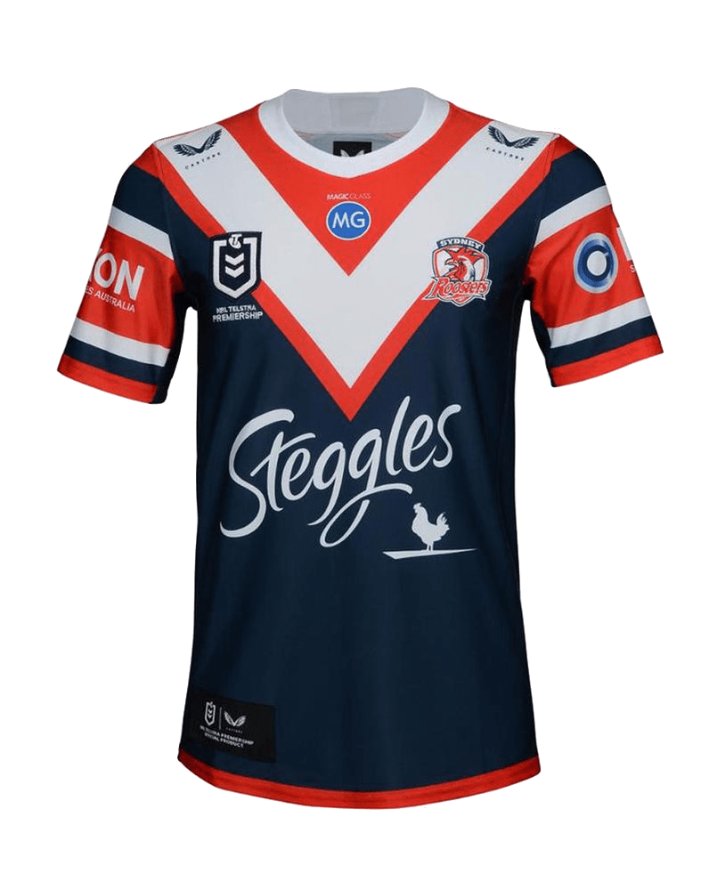
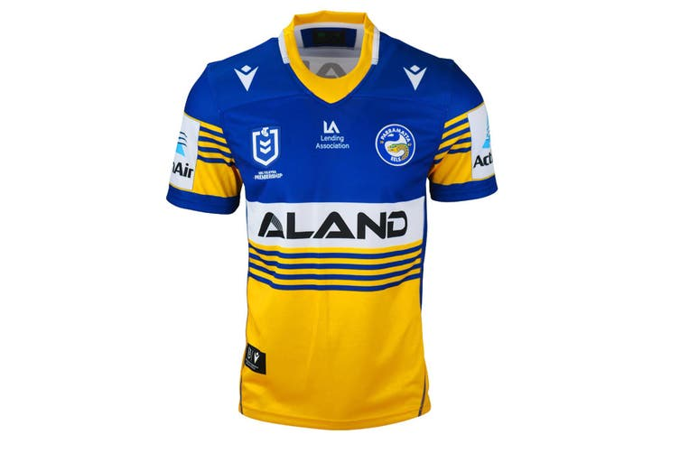
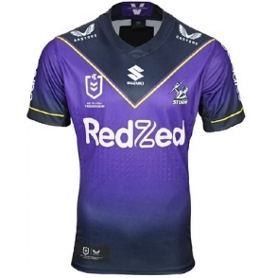
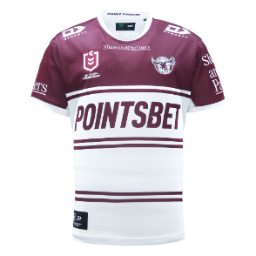
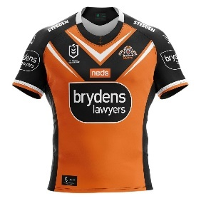
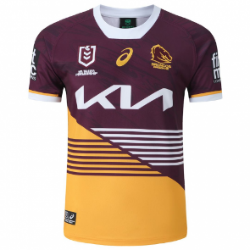
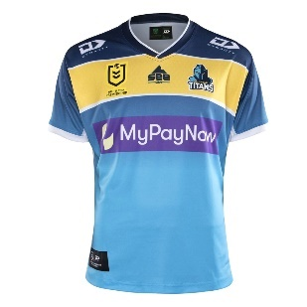
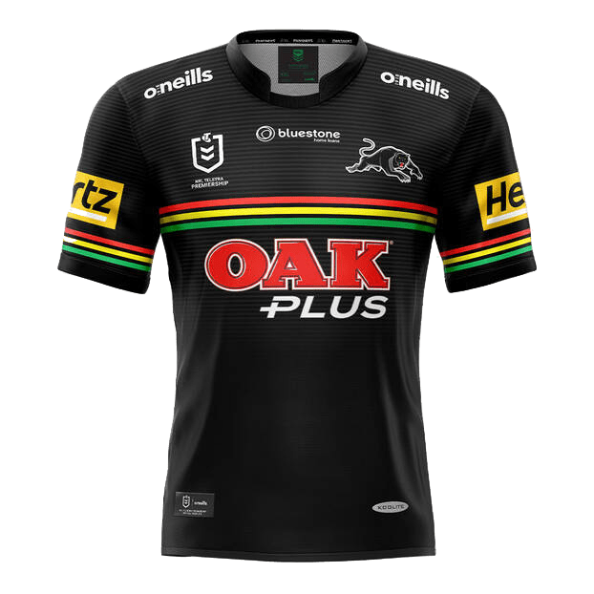
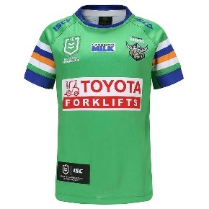
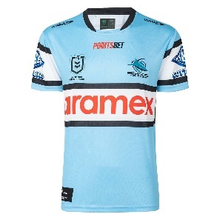
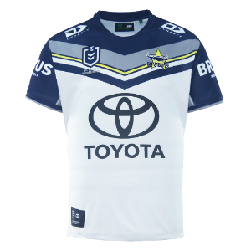
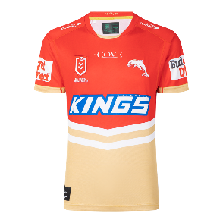
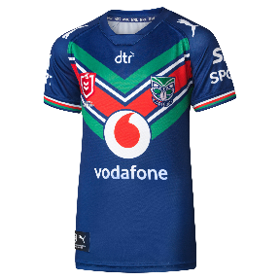
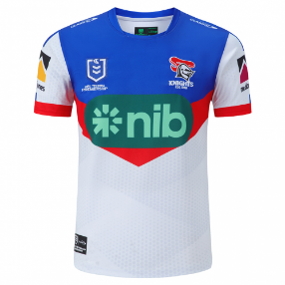
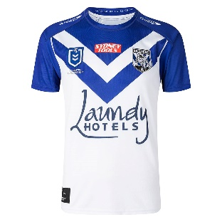
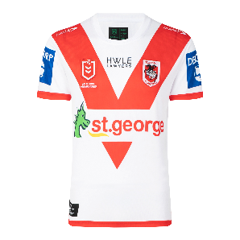

Activity 2
Write a sentence in Indonesian about what colours your favourite team wears.

Example: Regu/Tim favorit saya memakai kaos berwarna merah, putih dan biru.

……………………………………………………………………………………………………

…………………………………………………………………………………………………..

Topic: Nomer (Numbers)

satu | 1
dua | 2
tiga | 3
empat | 4
lima | 5
enam | 6
tujuh | 7
delapan | 8
sembilan | 9
sepuluh | 10
belas | word for all teen numbers
sebelas | 11
duabelas | 12
tigabelas | 13
puluh | word for all tens numbers
duapuluh | 20
duapuluh lima | 25
ratus | word for all hundred numbers
seratus | 100
dua ratus | 200
ribu | word for all thousand numbers
seribu | 1000
dua ribu | 2000

Activity 1
Here is the NRL ladder at the end of the 2022 season.

Fill in the table below with the total points each team finished with in Indonesian numbers. The first two have been done for you.
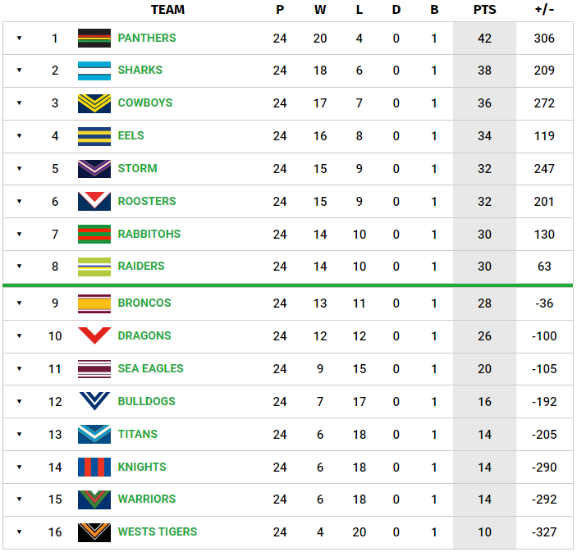

Klasemen | Regu/Tim | Poin
Pertama | Harimau Kumbang Penrith | empatpuluh dua(42)
Kedua | Ikan Hiu Cronulla | tiga puluh delapan (38)

Activity 2
Look at the top 8 teams.

Write their points difference in Indonesian numbers. The first one has been done for you.

Klasemen | Regu/Tim | Perbedaan Poin
Pertama | Harimau Kumbang Penrith | tiga ratus enam (306)
Kedua
Ketiga
Keempat
Kelima
Keenam
Ketujuh
Kedelapan

Topic: International Popularity of Rugby League:

Rugby league is played in over 70 nations throughout the world. Four countries – Australia, England, France, and New Zealand, – have teams that play at a professional level, while the rest are semi-professional, mainly in Papua New Guinea and Wales, or amateur. 45 national teams are ranked by the RLIF and a further 32 are officially recognized and unranked. The strongest rugby league nations are Australia, England, New Zealand, Samoa and Tonga. Two countries, Papua New Guinea and Cook Islands, have Rugby league as their national sport. The 2022 Men’s Rugby League World Cup, made up of 16 competing nations, was hosted by England during October and November 2022. Some NRL players who would have been eligible to play for Australia, decided instead to play for their country of heritage. Players from NRL squads featured in 13 of the 16 squads taking part in the men's Rugby League World Cup, with 155 players from the Telstra Premiership being involved and all 16 NRL clubs represented.

Below are the 16 teams involved in the Group Stage of the tournament.

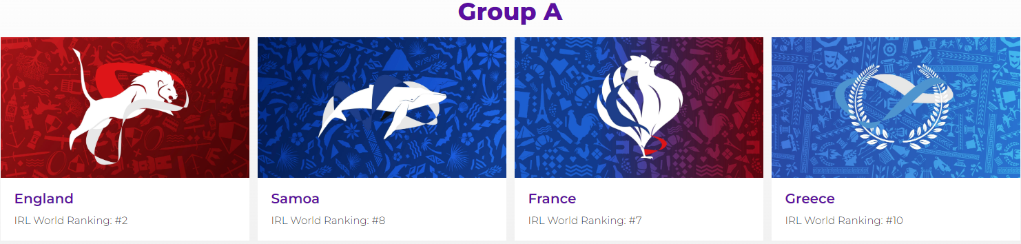

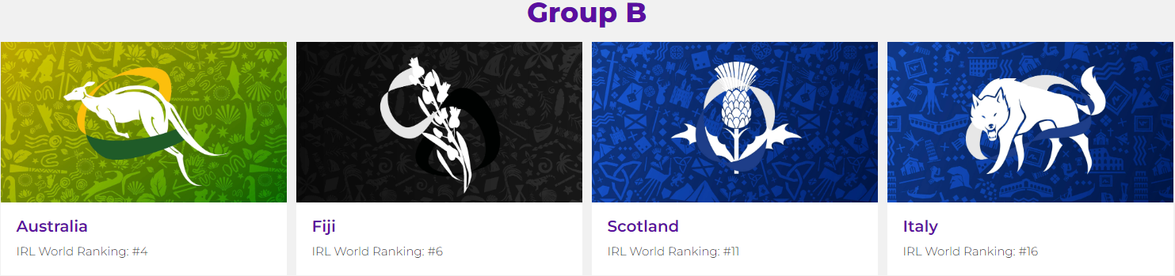

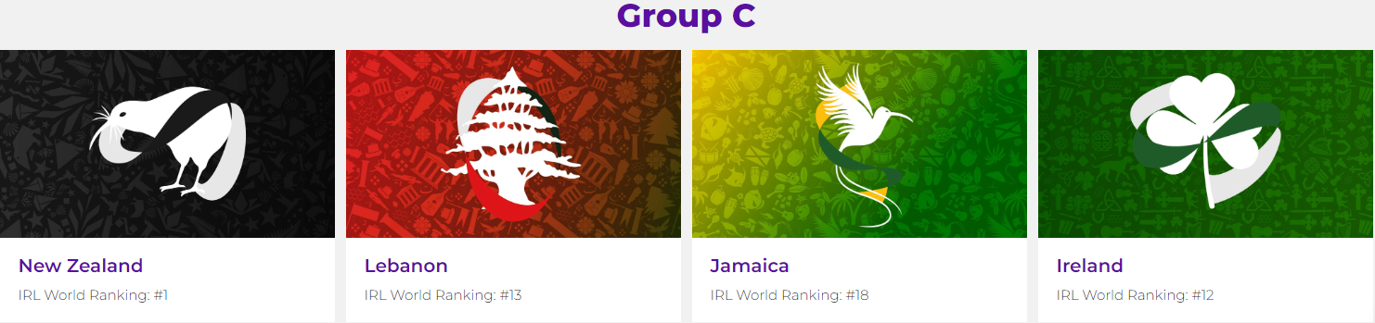

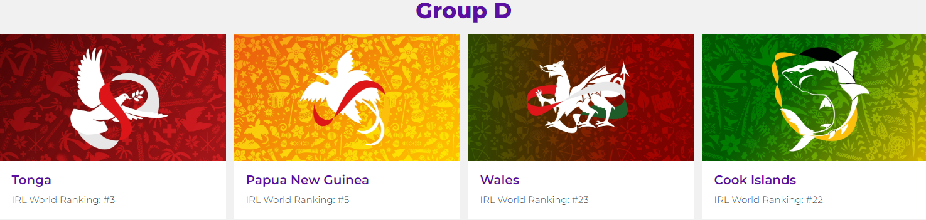

Activity 1

Select one country from each group and identify the country, team name and team colours in Indonesian. For example: Australia – Kanguru Australia – Hijau dan Emas.

Grup | Negara | Nama Tim Nasional | Warna Kaos Tim Nasional
Grup A
Grup B
Grup C
Grup D
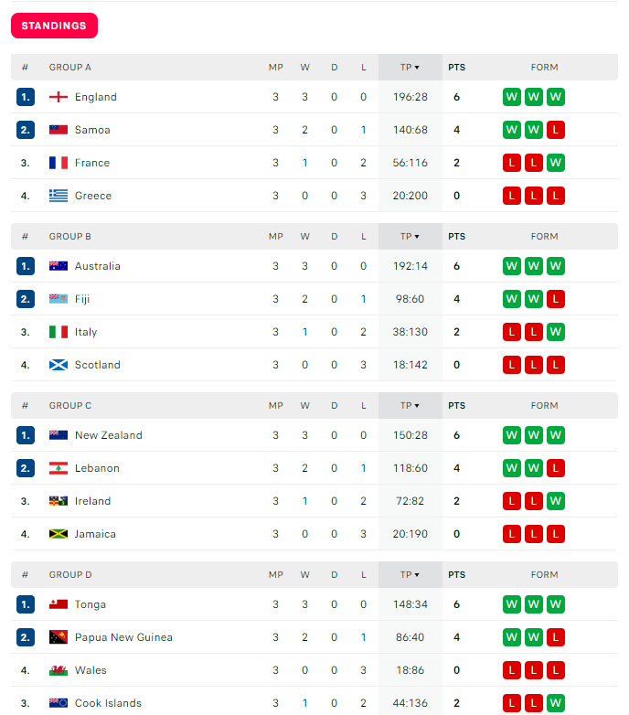

Activity 2

After the Group Stage of the tournament, record the points scored for (poin dicetak) and points scored against (poin kebobolan) in descending order from the top-scoring nation to the least scoring nation in words in Indonesian. The countries in the table have been named in Indonesian. If you are not sure of the name look it up using Google Translate.The first one has been done for you.

Negara | Poin Dicetak | Poin Kebobolan
Inggris | seratus sembilanpuluh enam | duapuluh delapan
Australia
Selandia Baru
Tonga
Samoa
Lebanon
Fiji
Papua Nugini
Irlandia
Perancis
Kepulauan Cook
Italia
Jamaika
Yunani
Wales
Skotlandia

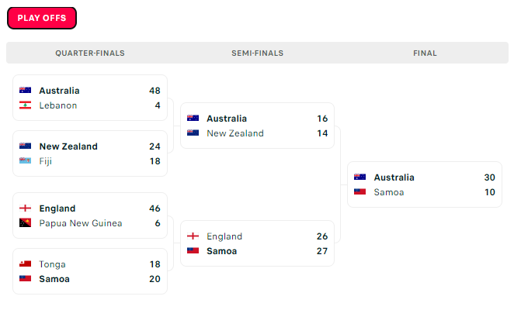
Activity 3

After the Play-Off Stage of the tournament, record the points scored for (poin dicetak) and points scored against (poin kebobolan) in descending order from the top-scoring nation to the least scoring nation in words in Indonesian. The first one has been done for you.

Negara | Poin Dicetak | Poin Kebobolan
Australia | sembilanpuluh empat | duapuluh delapan
Inggris
Samoa
Selandia Baru
Tonga
Fiji
Papua Nugini
Lebanon

Activity 4

International Rugby League Research
Go to this website (or any other you can find) https://www.intrl.sport/ and answer these questions:

- What are the ten countries in the Asia Pacific Region that play Rugby League?
Write the names of these counties in Indonesian using Google Translate if needed.

…………………………………………………………………………………………….
…………………………………………………………………………………………….
…………………………………………………………………………………………….

- From your knowledge of Indonesian people and their culture, why do you think Rugby
League has not gained a foothold in Indonesia?

…………………………………………………………………………………………….
…………………………………………………………………………………………….

- What are the nine countries in the Americas that play Rugby League? Write the
names of these counties in Indonesian using Google Translate if needed.

…………………………………………………………………………………………….
…………………………………………………………………………………………….
…………………………………………………………………………………………….

- What are the twenty-eight countries in Europe that play Rugby League? Write the
names of these counties in Indonesian using Google Translate if needed.

…………………………………………………………………………………………….
…………………………………………………………………………………………….
…………………………………………………………………………………………….
…………………………………………………………………………………………….
…………………………………………………………………………………………….
…………………………………………………………………………………………….

- What are the fourteen countries in the Middle East and Africa that play Rugby League? Write the names of these counties in Indonesian using Google Translate if needed.

…………………………………………………………………………………………….
…………………………………………………………………………………………….
…………………………………………………………………………………………….
…………………………………………………………………………………………….

- What are the current Top Ten ranked Rugby League Nations? Complete the table below
in Indonesian using Google Translate if needed. The first one has been done for you.

Nomor Peringkat | Nama Negara
Pertama | Australia
Kedua
Ketiga
Keempat
Kelima
Keenam
Ketujuh
Kedelapan
Kesembilan
Kesepuluh

Topic: Establishing Rugby League in Indonesia

Below are the logos of some of the Rugby League playing nations:

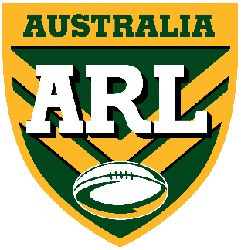 | 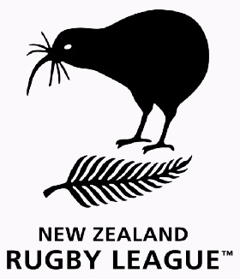 | 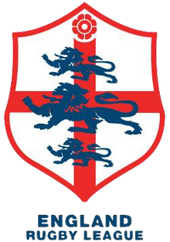
Australia | Selandia Baru | Inggris | Perancis
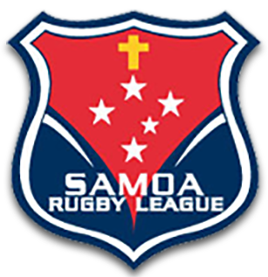 | 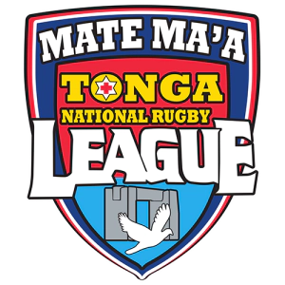 | 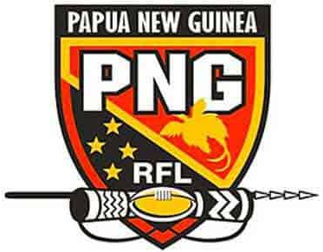
Samoa | Tonga | Papua Nugini | Lebanon

Task 1 – Use your knowledge of Indonesian culture to design a logo for a yet-to-be-
established Indonesian National Rugby League (INRL) Some of the national images
or icons below might give you some Inspiration.

Make sure you meet the following criteria:
- Must have the words “Indonesia NRL”
- Must represent Indonesia as a country, e.g. use Indonesian icons in the design to make it unique to Indonesia
- Must stand out as INDONESIA NRL!
Draw your FINAL design in the box below.

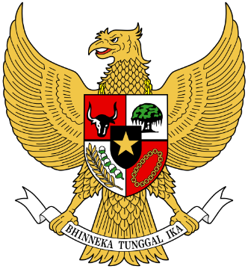 | 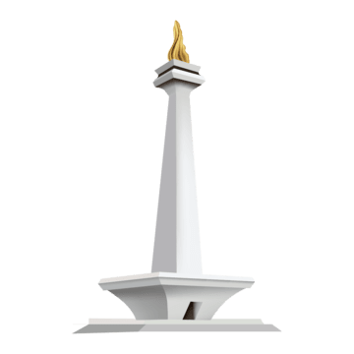 | 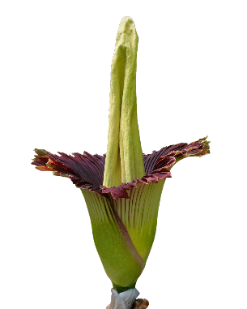 | 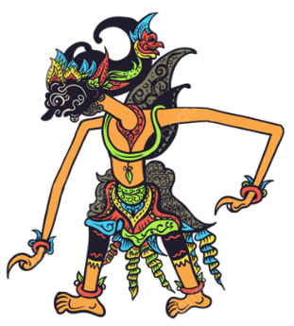
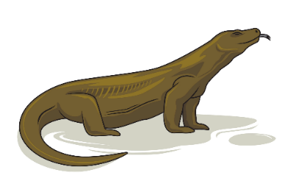 | 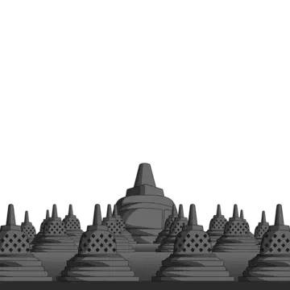 | 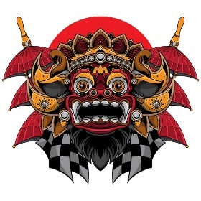 | 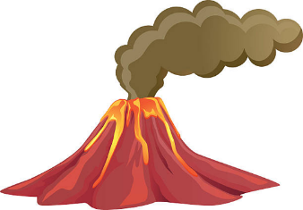
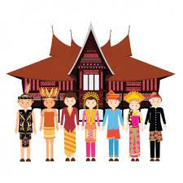 | 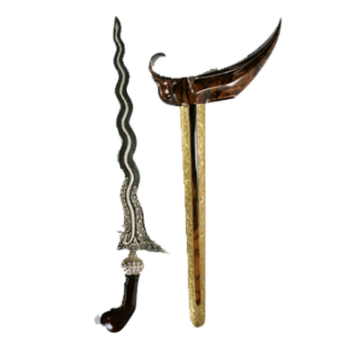 |  | 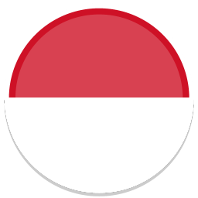
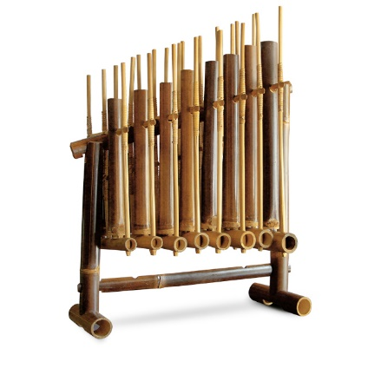 | 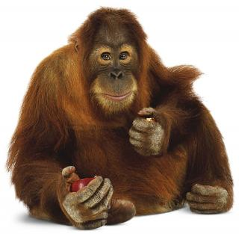 | 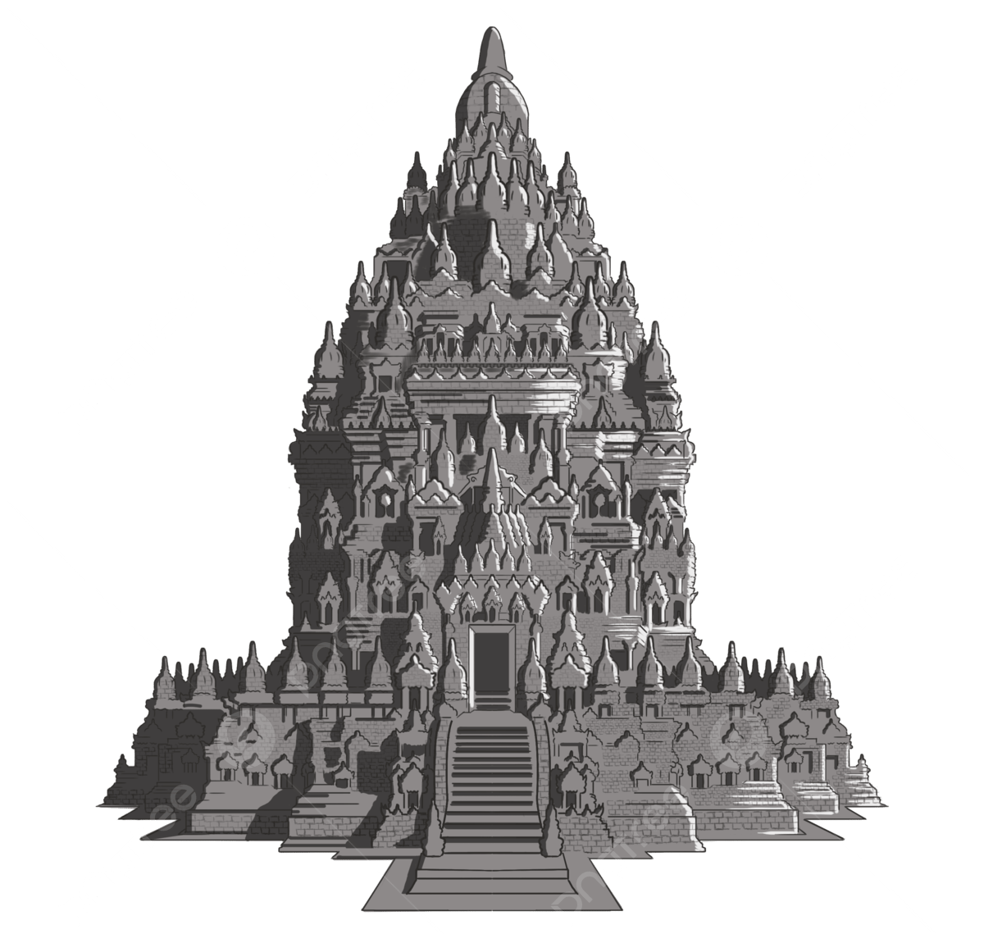

Task 2 – Imagine the Rugby League clubs throughout Australia have been provided
with funding from the Australian Rugby League (ARL) to help set up teams throughout
the Indonesian archipelago so all the major cities and islands are represented.

Complete this table with information about the potential teams in the INRLI:

Team Name  in English | Team Name  in Indonesian | Team Colours | From Which City | From Which Island
Jakarta
Jets
Surabaya Sharks
Bandung
Bears
Bekasi
Bulldogs
Semarang
Stars
Medan
Mandrills
Bali
Broncos
Lombok
Lions
Kalimantan
Kings
Pontianak
Peacocks
Sulawesi
Sultans
Manado
Magpies
Sumatra
Storm
Papua
Pirates

Task 3 – Select one of the clubs from the list above and create the club logo and design the team jersey for the club in the boxes provided below. Don’t forget to include the logo of the club’s major sponsor on your jersey. Think of some popular Indonesian brands as potential sponsors or select one from the list below:
 |  | 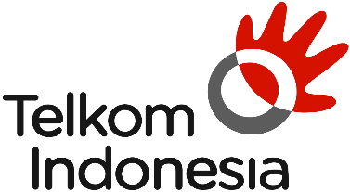 | 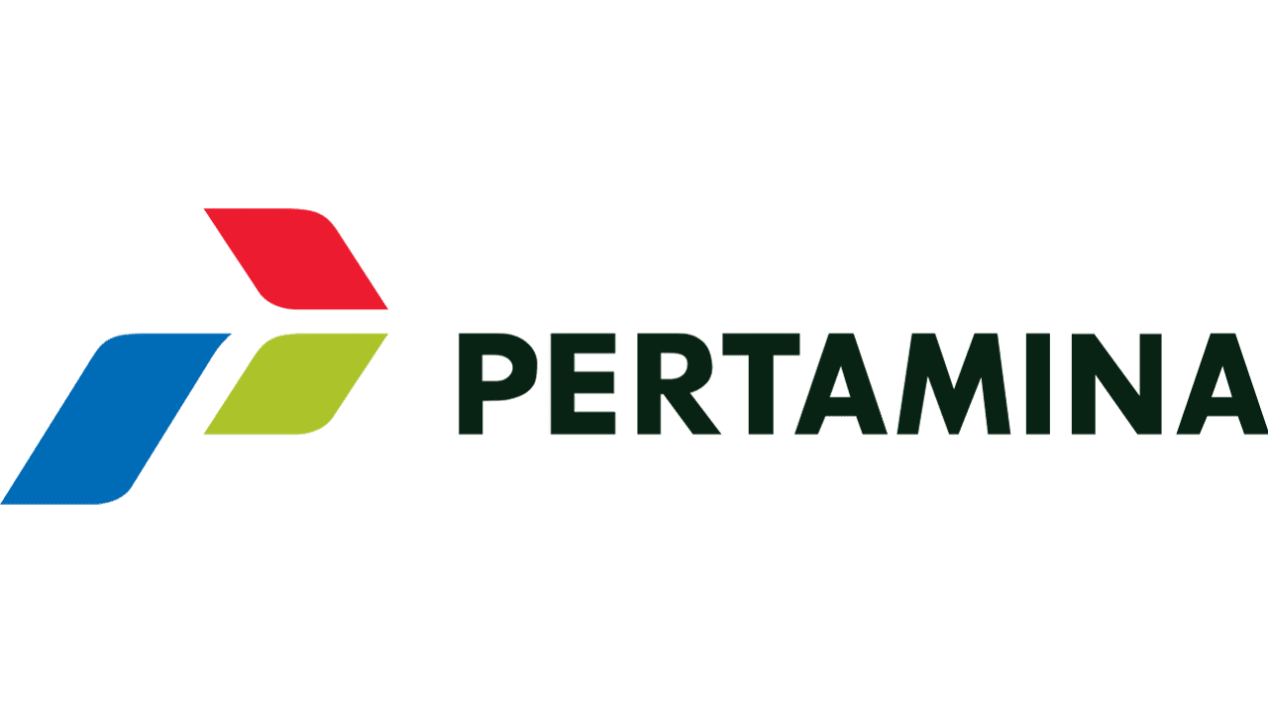
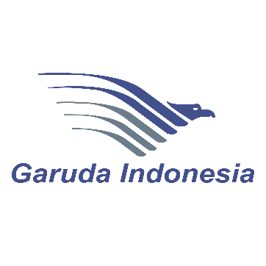 |  |  | 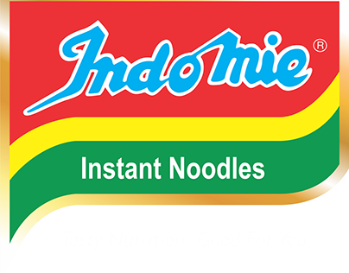
 | 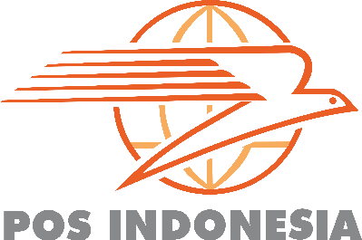 |  | 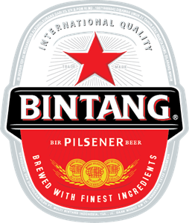

A sample team logo has been provided below:

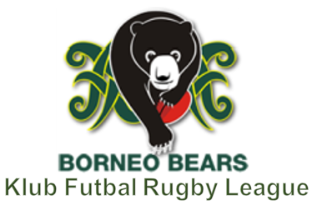

Team Logo | Team Jersey

